**Do the following Tasks:**

**Task 1:**

1. **Identify the main components of the given Digital Kit Products model (A) and Model (B) as shown in Figure (1), Compare and contrast between the two models, which one is described in the scenario.**

Kit (A) Components:

1. 4x4 Matrix Keyboard:
   1. Input user data or perform specific actions by pressing differentcombinations
2. Digital Logic Processor (DLC):
   1. Is a specialized Microcontroller chip, with its architecture is optimized for carrying out logic functions.
3. Arduino Uno R3, Consists of:

* Micro controller
* Power input
* Analog input
* Power Supply

1. Cables and wires
2. LCD 16x2:
   1. Print messages or prompts for user interaction in your projects
3. 7-seg Display:
   1. Display numbers or letters
   2. Show sensor values gas level (in this example)

**Kit (B) Components:**

1. Seven-Segment Mini Board
2. 7-seg Display:
   1. Display numbers or letters
   2. Show sensor values gas level (in this example)
3. Buzzer:
   1. Create an alarm system for security or safety purposes.
   2. Use it for generating different tones or melodies for notifications
4. Gas sensor:
   1. Detect gas/smoke presence in the environment.
5. Led input/output:
   1. Use as indicators to show the status of a system (on/off, active/inactive, etc.).
   2. Create visual feedback for different actions or events in your project.

Model A was described in the scenario

1. **For the given logic function, explain its operation, make a good use of Boolean algebra and Truth Tables. And, sketch the logic diagram of the given logic function.**

**Q = (A’BC’+A’B’C)’**

Truth table:

|  |  |  |  |  |  |  |  |  |  |
| --- | --- | --- | --- | --- | --- | --- | --- | --- | --- |
| A | B | C | A’ | B’ | C’ | A’BC’ | A’B’C | A’BC’+A’B’C | Q |
| 0 | **0** | **0** | **1** | **1** | **1** | **0** | **0** | **0** | **1** |
| 0 | **0** | **1** | **1** | **1** | **0** | **0** | **1** | **1** | **0** |
| 0 | **1** | **0** | **1** | **0** | **1** | **1** | **0** | **1** | **0** |
| 0 | **1** | **1** | **1** | **0** | **0** | **0** | **0** | **0** | **1** |
| 1 | **0** | **0** | **0** | **1** | **1** | **0** | **0** | **0** | **1** |
| 1 | **0** | **1** | **0** | **1** | **0** | **0** | **0** | **0** | **1** |
| 1 | **1** | **0** | **0** | **0** | **1** | **0** | **0** | **0** | **1** |
| 1 | **1** | **1** | **0** | **0** | **0** | **0** | **0** | **0** | **1** |

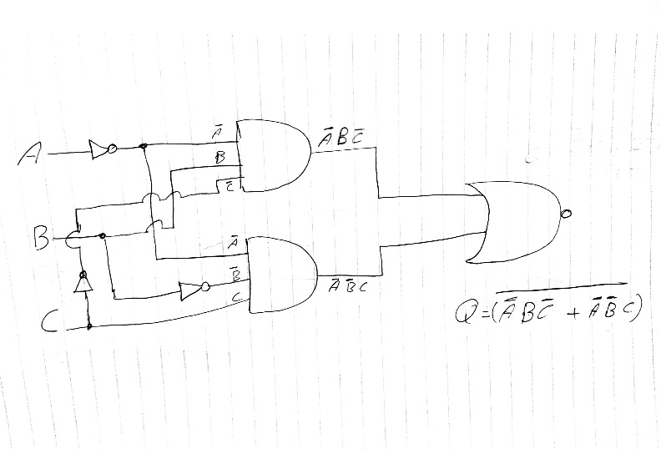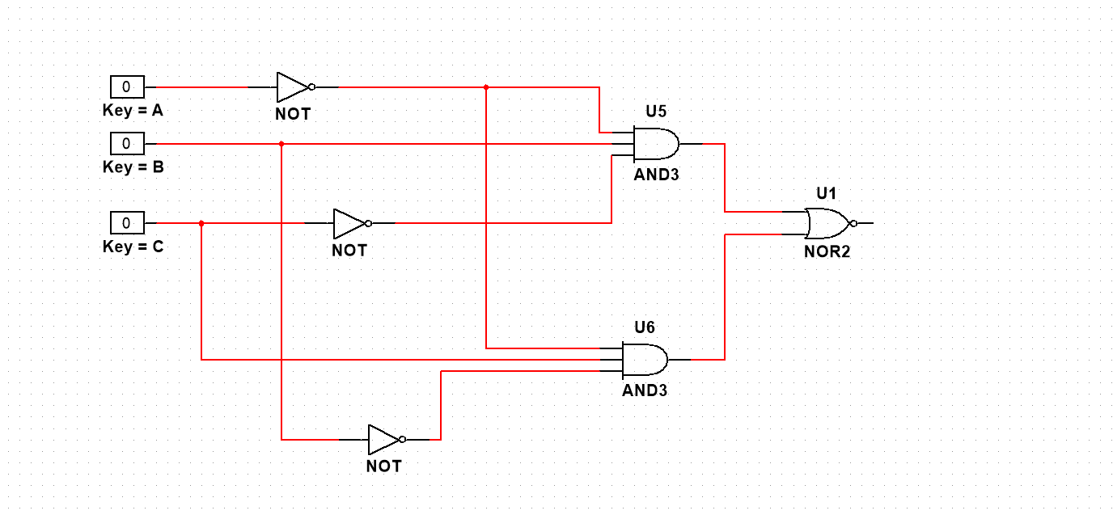

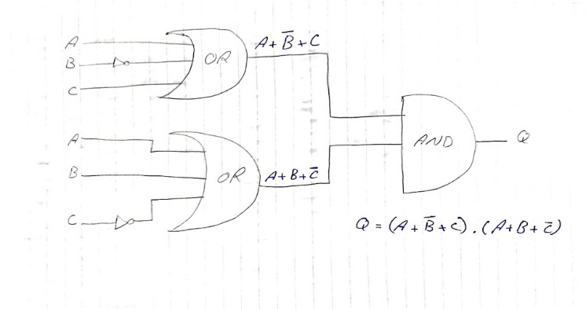

1. **Convert the decimal input to the binary format. And the output to hexadecimal format.**

**Decimal to Binary:**

|  |  |  |  |  |
| --- | --- | --- | --- | --- |
|  | C | B | A | Q = (A+B’+C) .(A+B+C’) |
| 6 | **1** | **1** | **0** | **Q1 = (0+0+1).(0+1+0) = (1.1) = 1** |
| 3 | **0** | **1** | **1** | **Q2 = (1+0+0).(1+1+1) = (1.1) = 1** |
| 2 | **0** | **1** | **0** | **Q3 = (0+0+0).(0+1+1) = (0.1) = 0** |
| 5 | **1** | **0** | **1** | **Q4 = (1+1+1).(1+0+0) = (1.1) = 1** |

**Binary to Hexadecimal:**

|  |  |
| --- | --- |
| 1011 | 11=B |

**4. Critically analyze the input and output methods for the Boolean expression of the given logic function when it has been processed using kit model (A) and model (B) in terms of component blocks in each kit as shown in Figure (1).**

In model (A):

You can enter decimal number input by using 4x4 matrix keypad it’s limited to the number 7 because the given function having only 3 binary inputs, this problem can be fixed by changing the logic function and make it have just 4 binary inputs after it the output will be shown on the LCD.

Meanwhile in model (B):

You can’t enter any decimal number because 4x4 matrix keypad so it can’t be used with this logic function and can’t be used in this model to give out the needed output.

**Task 2:**

**1. Simplify the given logic function and write a step by step simplification process with Logic Rules. Then, check the simplified with the given function.**

Q = (A’BC’ + A’B’C)’

(A’BC’) ’ . (A’B’C) ’ (Apply DeMorgan’s Law)

(A’’+B’+C’’) . (A’’+B’’+C’) (Involution Law X’’ = X)

(A+B’+C) . (A+B+C’)

(AA+AB+AC’+B’A+B’B+B’C’+CA+CB+CC’) (Apply Idempotent Law XX=X)

(A+AB+AC’+B’A+B’B+B’C’+CA+CB+CC’) (Apply Complement Law XX’ = 0)

(A+AB+AC’+B’A+0+B’C’+CA+CB+0) (Apply Identity Law X+0 = X)

(A+AB+AC’+B’A+B’C’+CA+CB) (Apply Absorption Law X+(XY) = X)

(A+AC’+B’A+B’C’+CA+CB) (Apply Absorption Law again)

(A+ B’A+B’C’+CA+CB) (Apply it again)

(A+B’C’+CA+CB) (Apply it again)

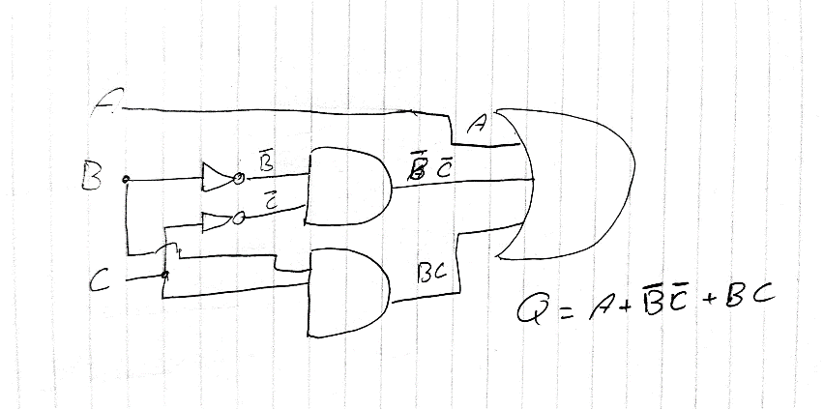 (A+B’C’+CB)

**Q = A+B’C’+CB**

The truth table:

|  |  |  |  |  |  |  |  |  |
| --- | --- | --- | --- | --- | --- | --- | --- | --- |
| A | B | C | B’ | C’ | B’C’ | CB | Q2 | Q1 |
| 0 | 0 | 0 | 1 | 1 | 1 | 0 | 1 | 1 |
| 0 | 0 | 1 | 1 | 0 | 0 | 0 | 0 | 0 |
| 0 | 1 | 0 | 0 | 1 | 0 | 0 | 0 | 0 |
| 0 | 1 | 1 | 0 | 0 | 0 | 1 | 1 | 1 |
| 1 | 0 | 0 | 1 | 1 | 1 | 0 | 1 | 1 |
| 1 | 0 | 1 | 1 | 0 | 0 | 0 | 1 | 1 |
| 1 | 1 | 0 | 0 | 1 | 0 | 0 | 1 | 1 |
| 1 | 1 | 1 | 0 | 0 | 0 | 1 | 1 | 1 |

Since Q1 is equivalent to Q2, then the simplification is true.

**2. Identify the Minterm and Maxterm terms of the given logic function.**

Minterm Maxterm

**A 1 A 0**

**A’ 0 A’ 1**

|  |  |  |  |  |  |  |  |
| --- | --- | --- | --- | --- | --- | --- | --- |
| A | B | C | Q | Minterm | | Maxterm | |
| **Term** | **Representation** | **Term** | **Representation** |
| 0 | 0 | 0 | 1 | A’B’C’ | m0 | A+B+C | M0 |
| 0 | 0 | 1 | 0 | A’B’C | m1 | A+B+C’ | M1 |
| 0 | 1 | 0 | 0 | A’BC’ | m2 | A+B’+C | M2 |
| 0 | 1 | 1 | 1 | A’BC | m3 | A+B’+C’ | M3 |
| 1 | 0 | 0 | 1 | AB’C’ | m4 | A’+B+C | M4 |
| 1 | 0 | 1 | 1 | AB’C | m5 | A’+B+C’ | M5 |
| 1 | 1 | 0 | 1 | ABC’ | m6 | A’+B’+C | M6 |
| 1 | 1 | 1 | 1 | ABC | m7 | A’+B’+C’ | M7 |

Q (SOP/Minterm) = ∑ (0, 3, 4, 5, 6, 7)

A’B’C’ + A’BC +AB’C’ +AB’C + ABC’ + ABC

Q (POS/Maxterm) = π (1, 2)

(A+B+C’).(A+B’+C)

**3. Represent the given logic function in terms of the Sum of Product (SOP) expression.**

Q (SOP/Minterm) = ∑ (0, 3, 4, 5, 6, 7)

A’B’C’ + A’BC +AB’C’ +AB’C + ABC’ + ABC

**4. Use Karnaugh Map (K-Map) to simplify the given logic function. Then, check the simplified with the given function output.**

**Logic function BY (SOP) =** A’B’C’ + A’BC + AB’C’ + AB’C + ABC’ + ABC

|  |  |  |  |  |
| --- | --- | --- | --- | --- |
|  | **B’ 0** | **B’ 0** | **B 1** | **B 1** |
| **A’ 0** | M0 = A’B’C’ | M1 = A’B’C | M3 = A’BC | M2 = A’BC’ |
| **A 1** | M4 = AB’C’ | M5 = AB’C | M7 = ABC | M6 = ABC’ |
|  | **C’ 0** | **C 1** | **C 1** | **C’ 0** |

**K-map = A+B’C’+BC**

**5. Evaluate the simplification method according to the worst-case simplification scenario.**

Simplify Q = (A’BC’+A’B’C)’ (Apply DeMorgan’s Law)

= (A’BC’)’.(A’B’C)’

= (A’’B’C’’).(A’’B’’C’) (Apply Involution Law X’’ = X)

= (AB’C).(ABC’) (Absorption Law)

= (AB’CABC’) (Complement Law XX’=0)

= 0

**Task 3: (In Lab Task)**

1. **Use Multisim simulator to simulate the given logic function and to test its operation.**

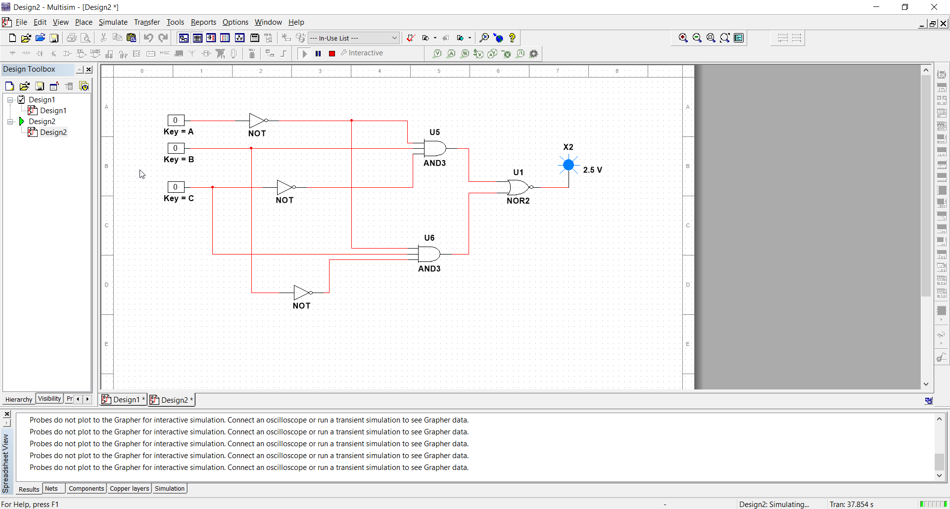**Q = (A+B’+C) . (A+B+C’)**

1. **Use advanced input methods to simulate the given logic function and test its operation in each case using Multisim simulator.**

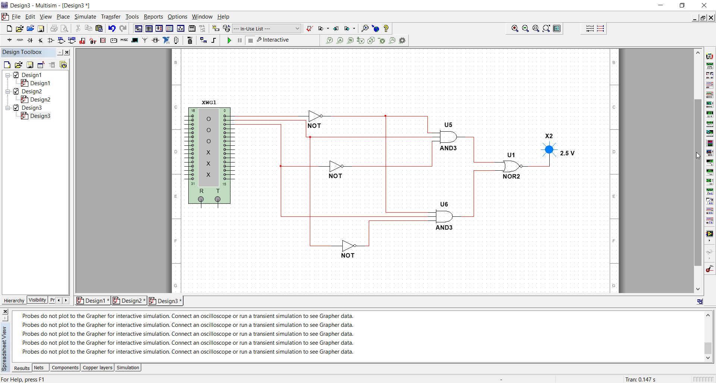

1. **Design a hardware implementation schematic and define the number of IC chips requirements for a Logic function implementation process in the given application scenario.**

• Printout the Logic diagram and its output.

